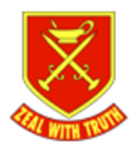

St Paul’s Church of England Primary School

PSHE
Long Term Curriculum 25-26

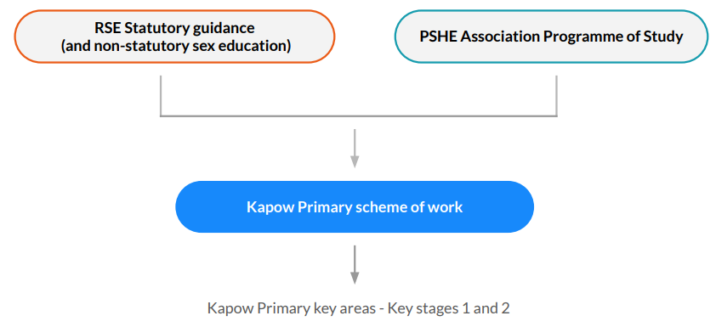
How the scheme is organised:

Key Areas
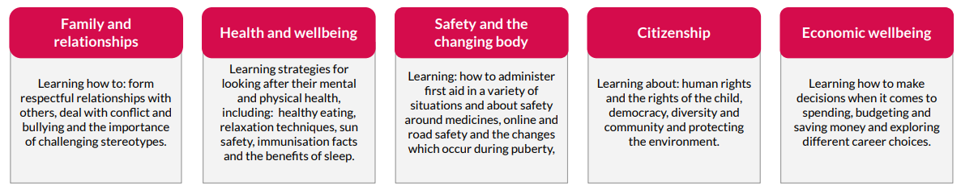
Kapow Primary organises PSHE lessons into five key areas, which are revisited each year to help build on pupils’ previous learning and prepare them for future learning. In Year 6, there is an additional focus area: Identity.

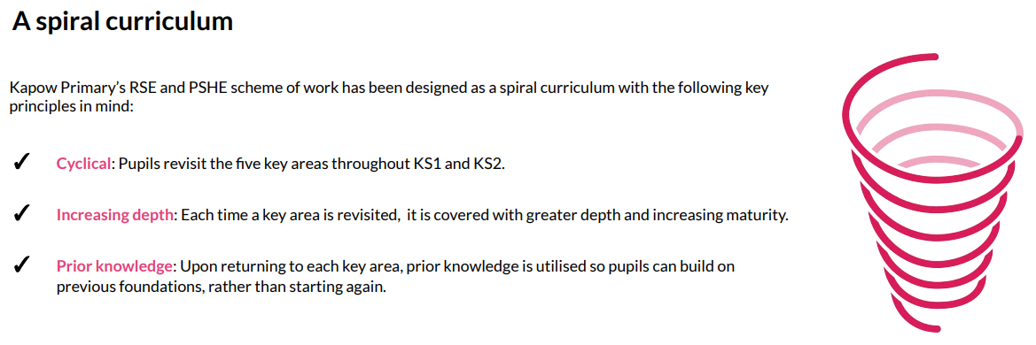
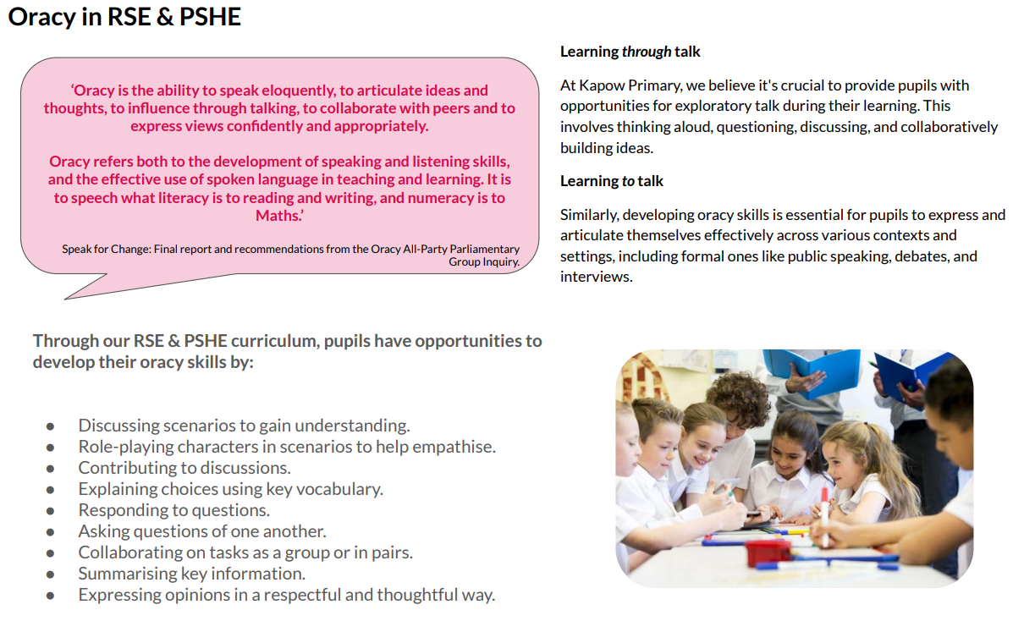

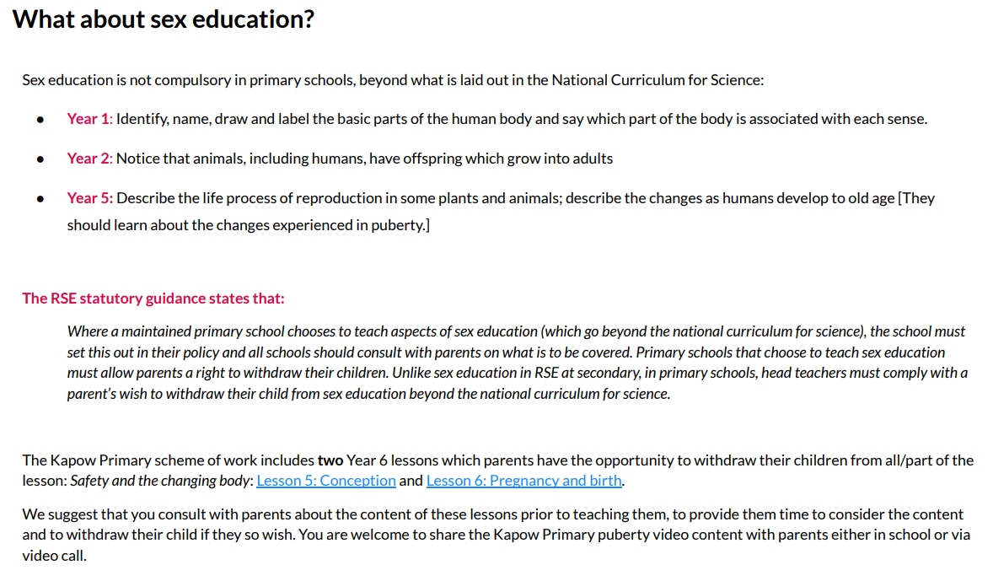

RSE & PSHE in EYFS: Reception
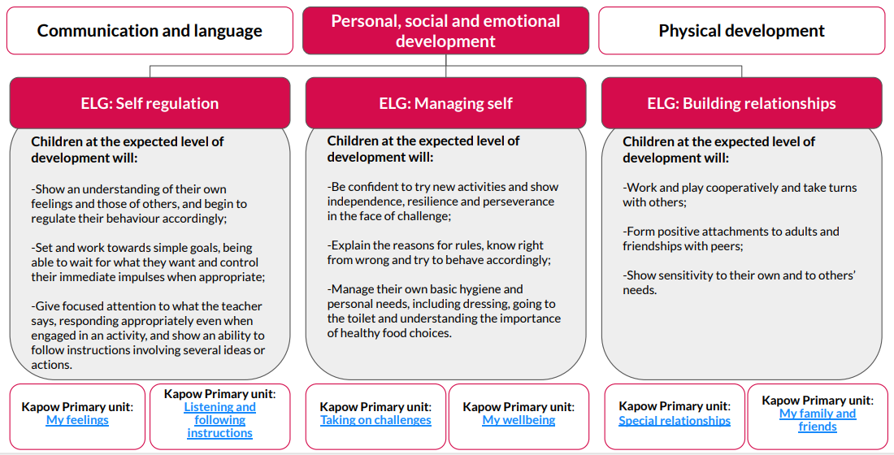
Personal, social and emotional development is one of the three Prime Areas in the Statutory framework for the early years foundation stage. The prime areas, Communication and language, Physical development and Personal, social and emotional development, lay the foundations for children to achieve in all areas of learning and life. The early learning goals (ELG) below summarise the knowledge, skills and understanding that all young children should have gained by the end of the reception year in the Personal, social and emotional development prime area and are referenced in our Kapow Primary RSE & PSHE lesson plans, along with the relevant non-statutory Development Matters guidance. We have organised our EYFS: Reception content under the most relevant early learning goal, however please be aware that these areas are interrelated.

RSE&PSHE - Termly Overview
Year Group | Autumn 1 | Autumn 2 | Spring 1 | Spring 2 | Summer 1 | Summer 2
EYFS | Self-Regulation: My feelings | Building Relationships:  My family and friends | Self-Regulation: Listening and following instructions | Building Relationships: Special relationships | Managing Self: Taking on challenges | Managing Self: My wellbeing
Year 1 | Introduction Lesson  Health and Wellbeing | Families and Relationships/  Anti-Bullying | Citizenship | Economic Wellbeing | Safety and the changing body | Transition
Year 2 | Introduction Lesson  Health and Wellbeing | Families and Relationships/  Anti-Bullying | Citizenship | Economic Wellbeing | Safety and the changing body | Transition
Year 3 | Introduction  Health and Wellbeing | Families and Relationships/  Anti-Bullying | Citizenship | Economic Wellbeing | Safety and the changing body | Transition
Year 4 | Introduction  Health and Wellbeing | Families and Relationships/  Anti-Bullying | Citizenship | Economic Wellbeing | Safety and the changing body | Transition
Year 5 | Introduction  Health and Wellbeing | Citizenship (Parliament Week) | Families and Relationships | Economic Wellbeing | Safety and the changing body | Transition
Year 6 | Introduction  Health and Wellbeing | Citizenship (Parliament Week) | Families and Relationships | Economic Wellbeing | Safety and the changing body | Identity/  Transition
*In accordance with the Kapow: RSE & PSHE scheme ©

